COMP 8967

User Manual

Submitted By Team Absolute Zero

Group 22

Under the Guidance of Dr.Kalyani Selvarajah

Table of Contents

1. Login ---------------------------------------------------------------------------------------------------------------------------- 3
2. File Operations --------------------------------------------------------------------------------------------------------------- 4 - 20
   1. Filter by Columns ----------------------------------------------------------------------------------------------------- 6 - 7
   2. Edit Data ---------------------------------------------------------------------------------------------------------------- 8 - 13
   3. Filter by Modules & Categories ----------------------------------------------------------------------------------- 14 - 16
   4. Add New File ----------------------------------------------------------------------------------------------------------- 17 - 18
   5. Check File History ----------------------------------------------------------------------------------------------------- 19 - 20
3. User Operations -------------------------------------------------------------------------------------------------------------- 21 - 26
4. Role Operations -------------------------------------------------------------------------------------------------------------- 27 - 28
5. Module & Category Operations ------------------------------------------------------------------------------------------ 29 - 31
6. Logout --------------------------------------------------------------------------------------------------------------------------- 32
7. Forgot Password -------------------------------------------------------------------------------------------------------------- 33 - 36

Login

2

On the Login Page, input your registered Username and Password.

Note: Only registered users can log in.

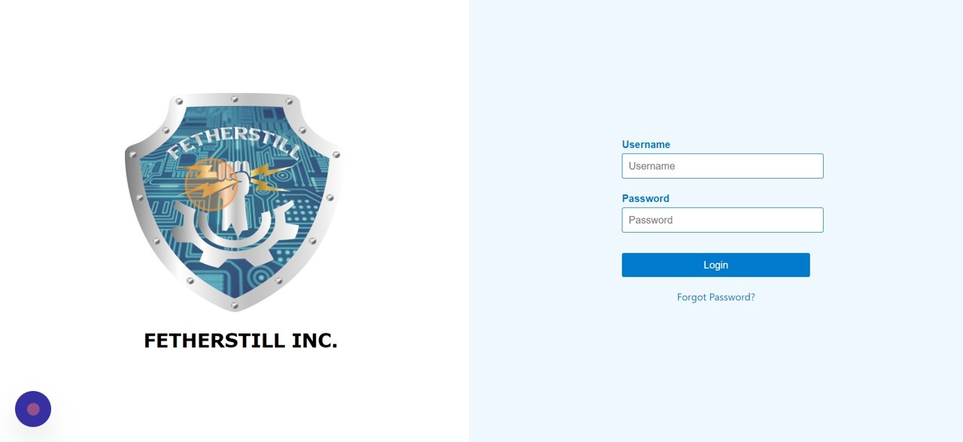

3

Click "Home"

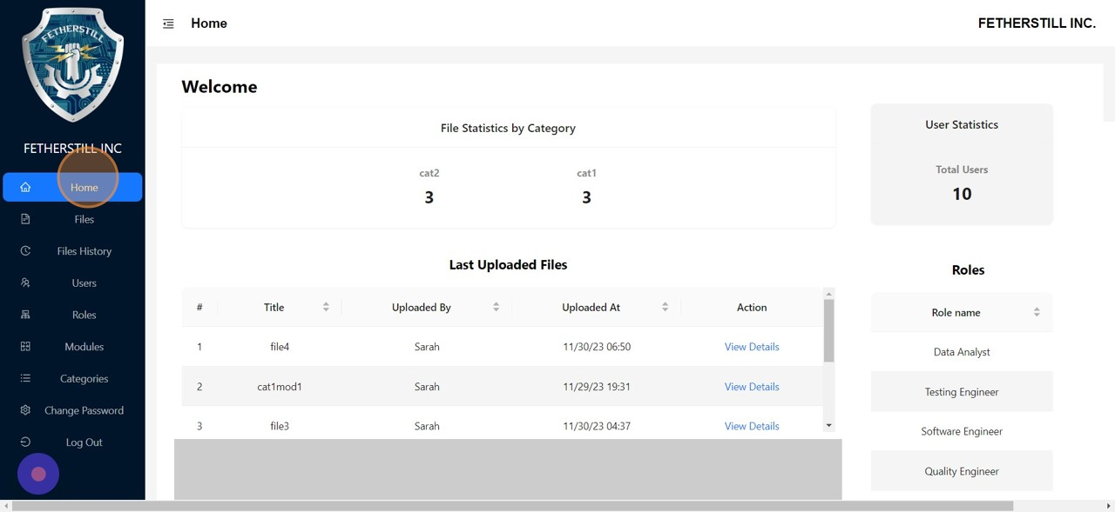

File Operations

4

Click

Files

to view the list of uploaded files.

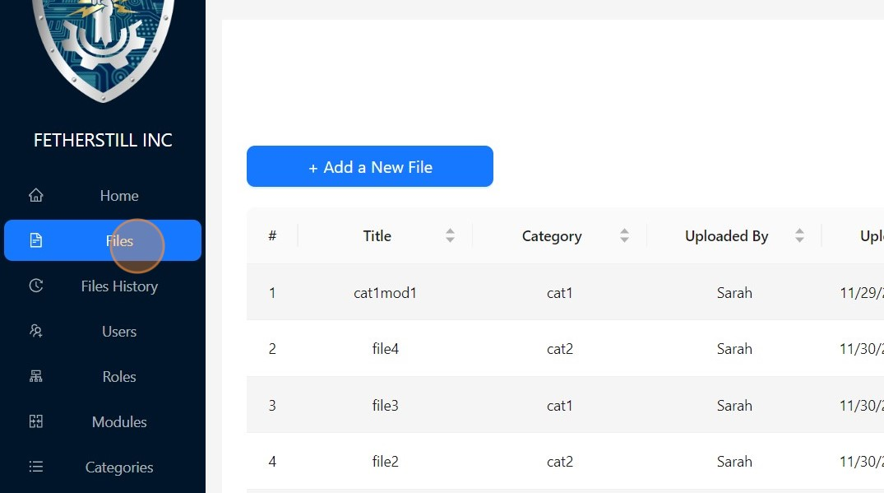

5

Click "View Details"

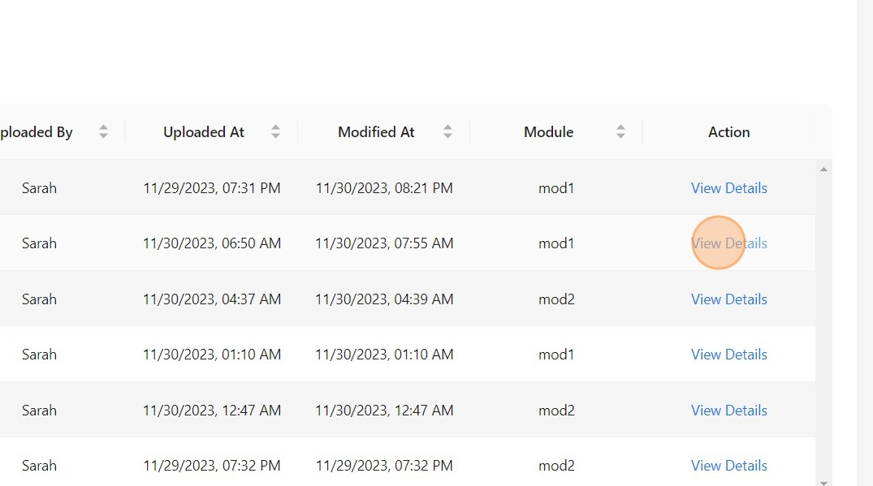

6

Toggle the switch to the ON position to display the details of the file.

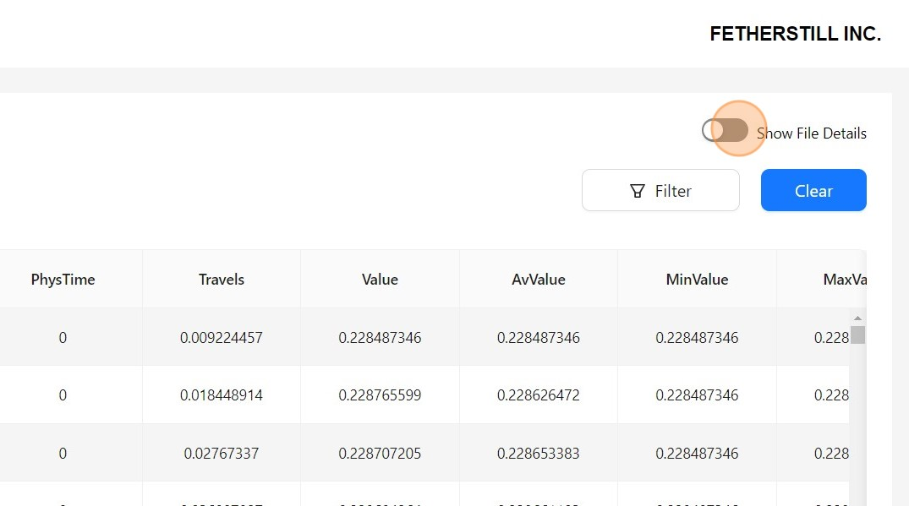

Filter by Column

7

Click

Filter

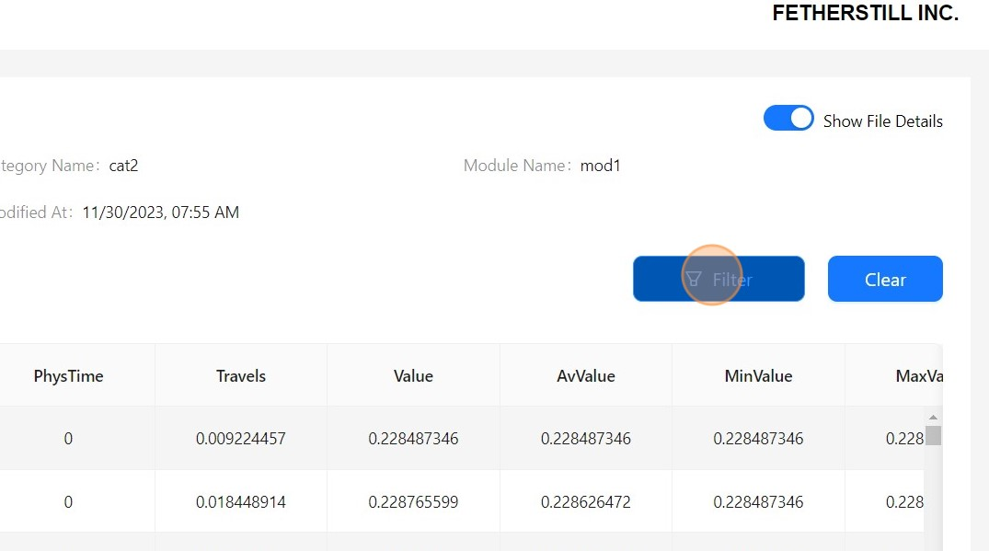

8

Fill in the form to filter based on either value or range.

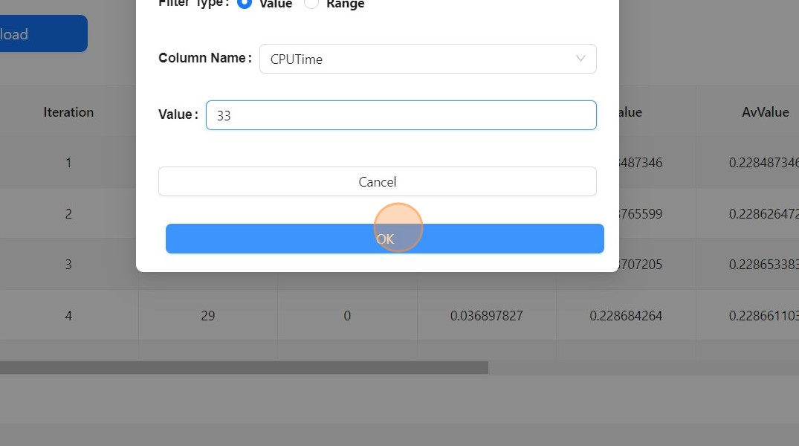

9

The filtered data is displayed.

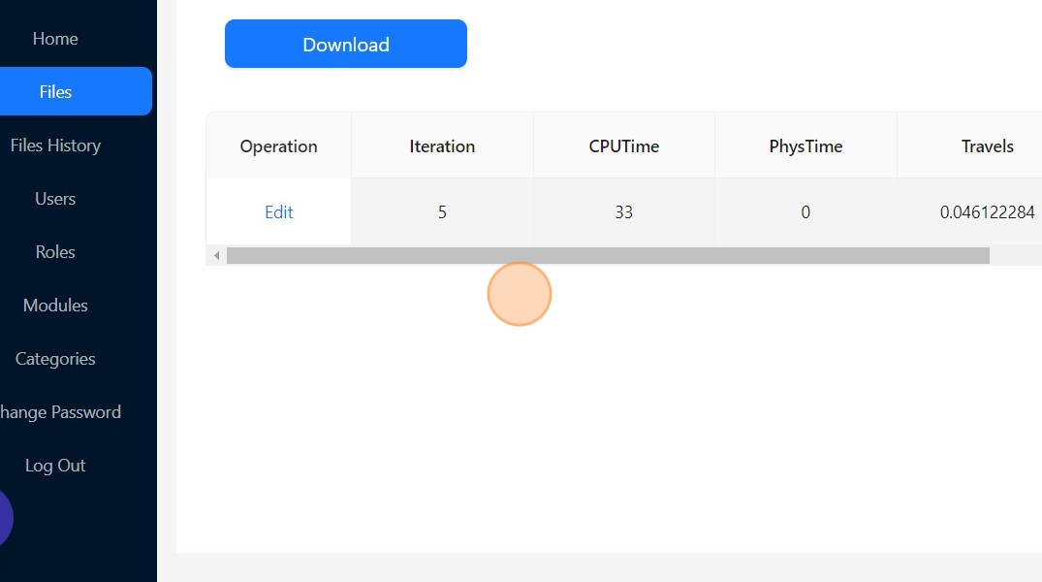

Edit Data

10

Click this text field to edit the value in a cell.

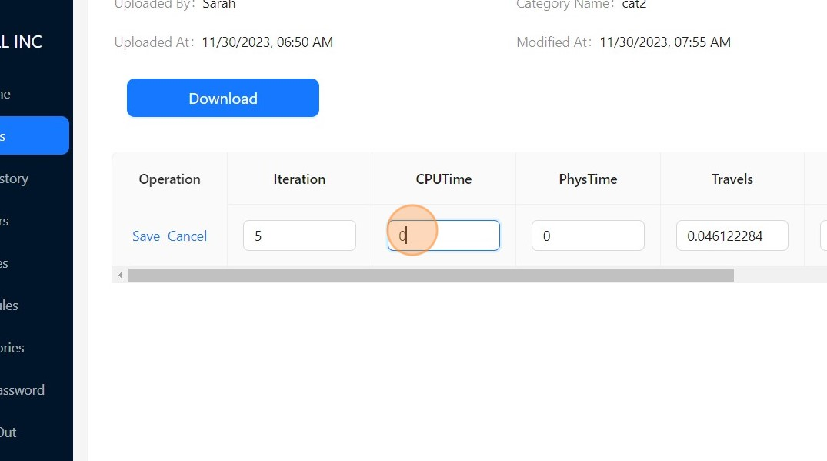

11

Click

Save

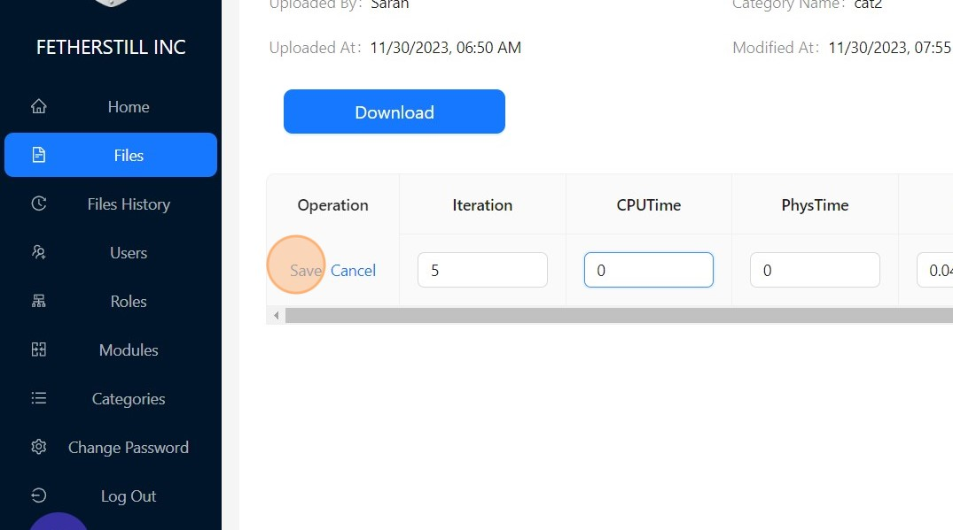

12

Data updated successfully.

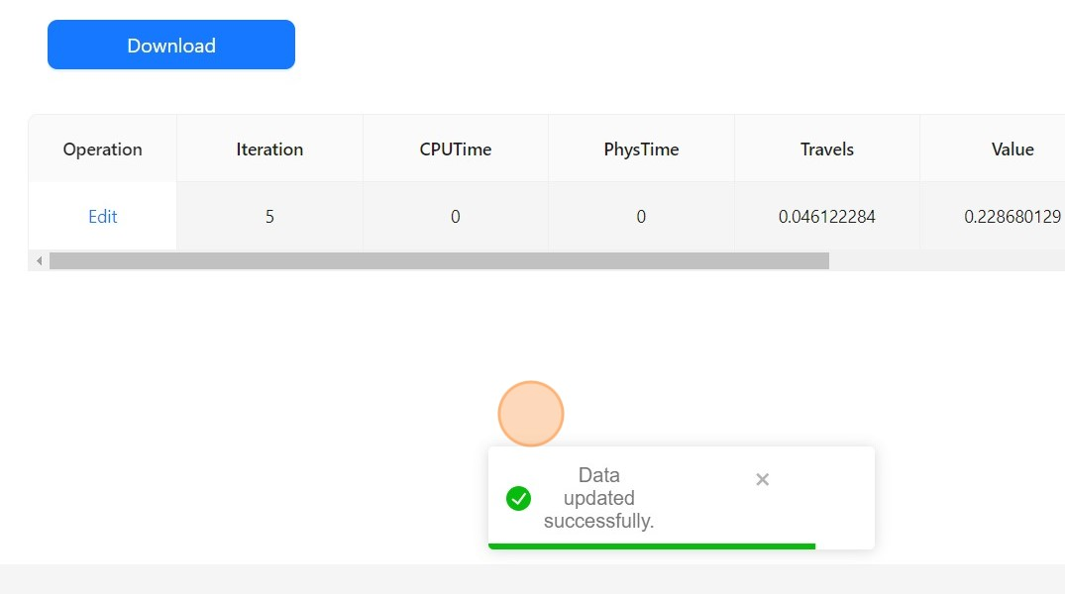

13

Click

Clear

to remove the filter.

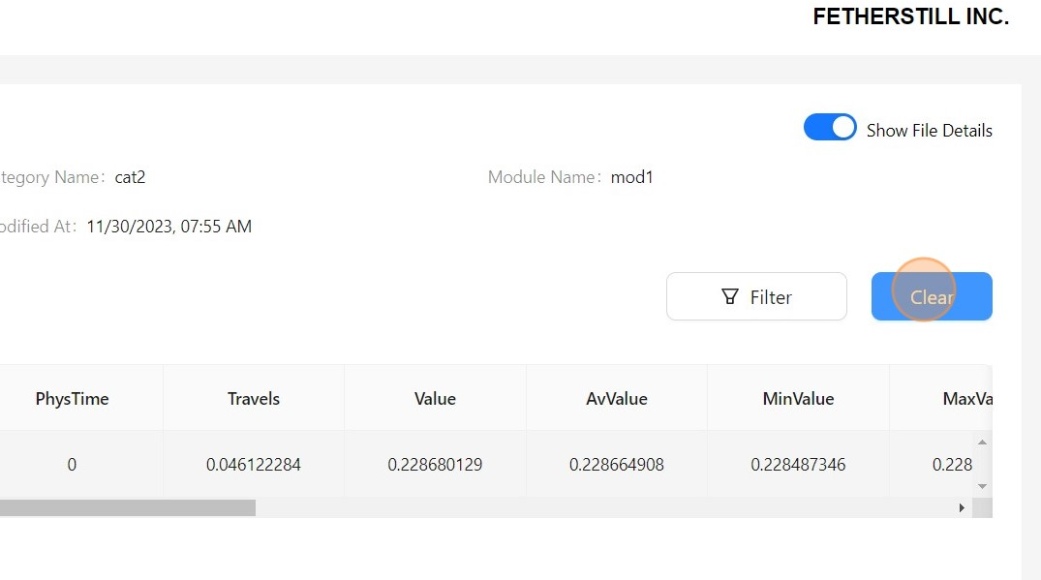

14

Click

Download

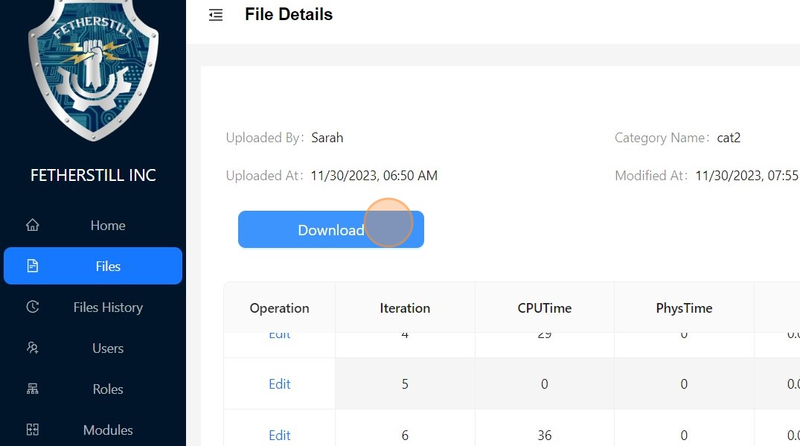

15

Choose a desired format to download the file and then click

OK

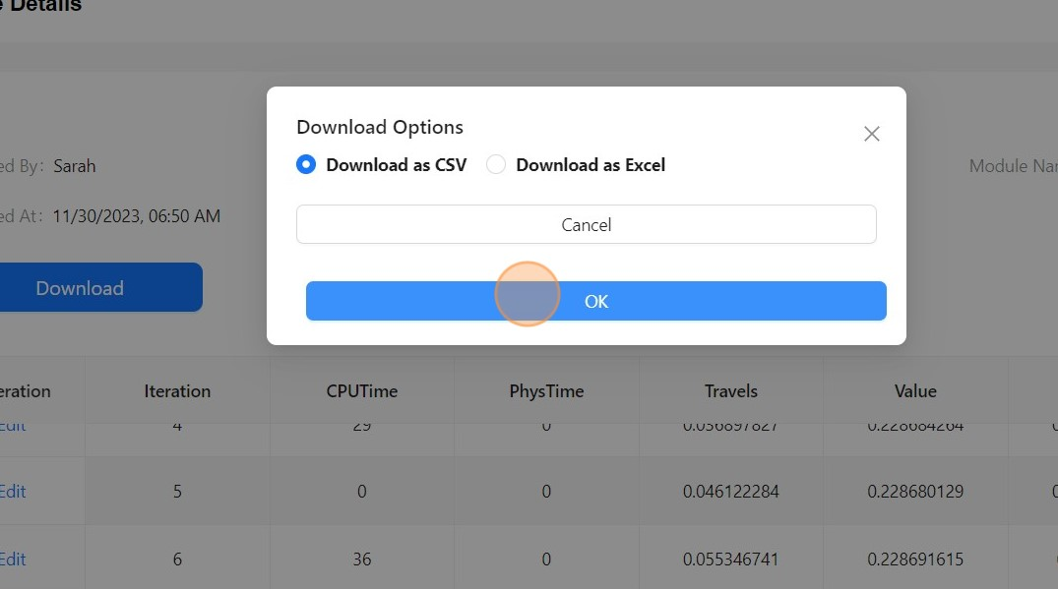

Filtration by Modules & Categories

16

You can also filter the files based on Modules and/or Categories.

17

Choose from the list of Modules.

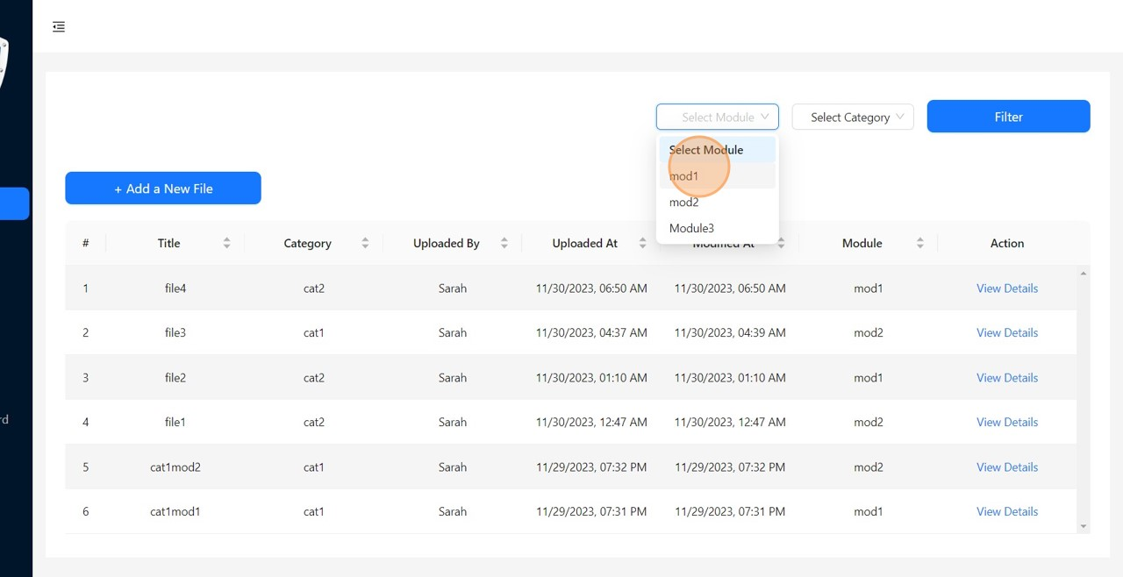

18

Click

Filter

to display a list of files filtered based on the selected module.

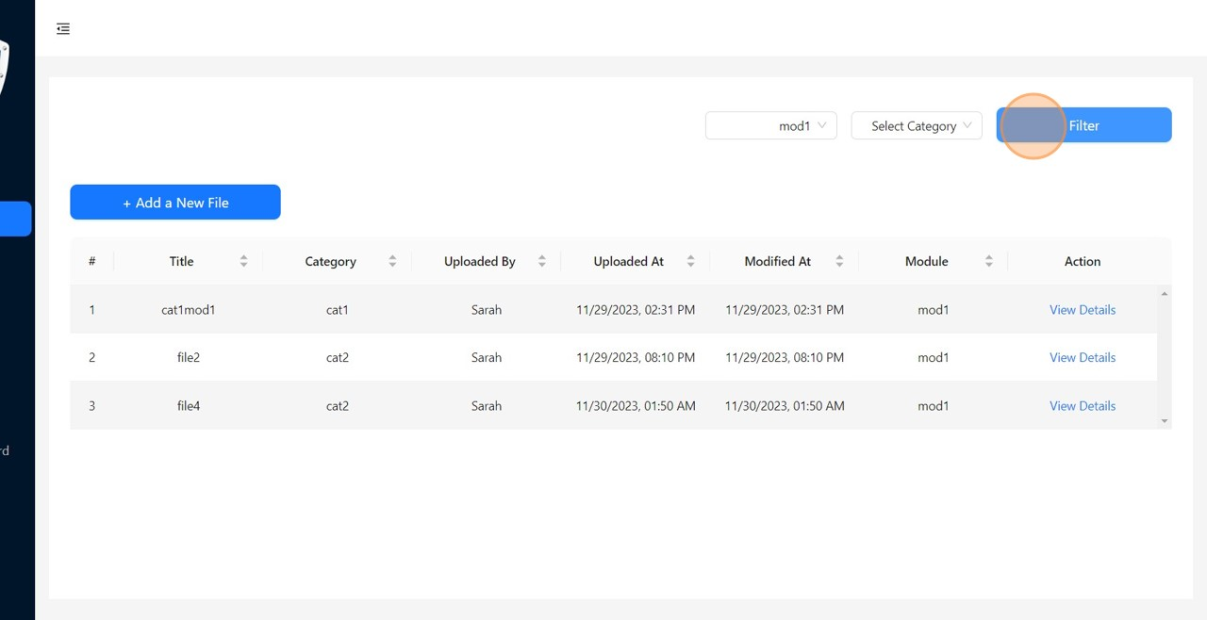

19

Or choose from the list of Categories.

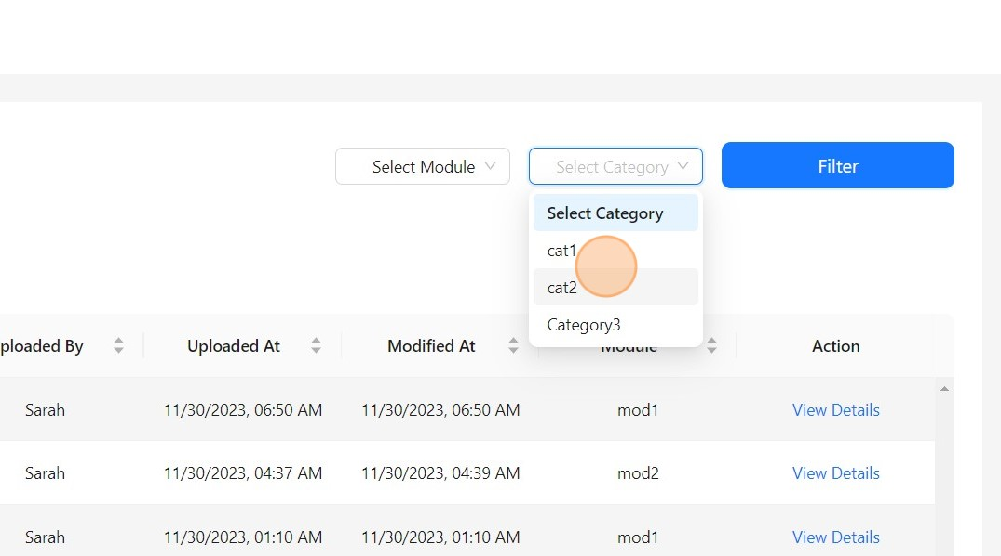

20

Click

Filter

to display a list of files filtered based on the selected category.

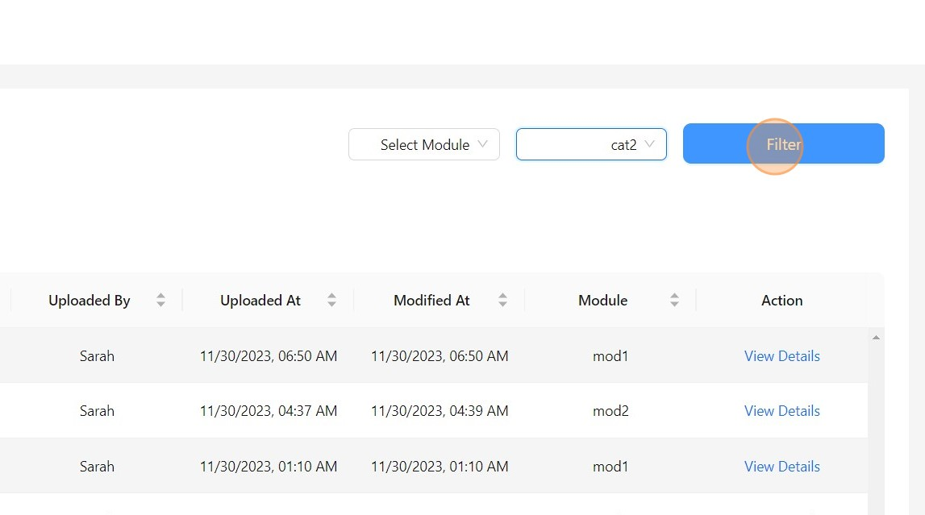

21

Or select from both the module and category lists to customize your file filtering.

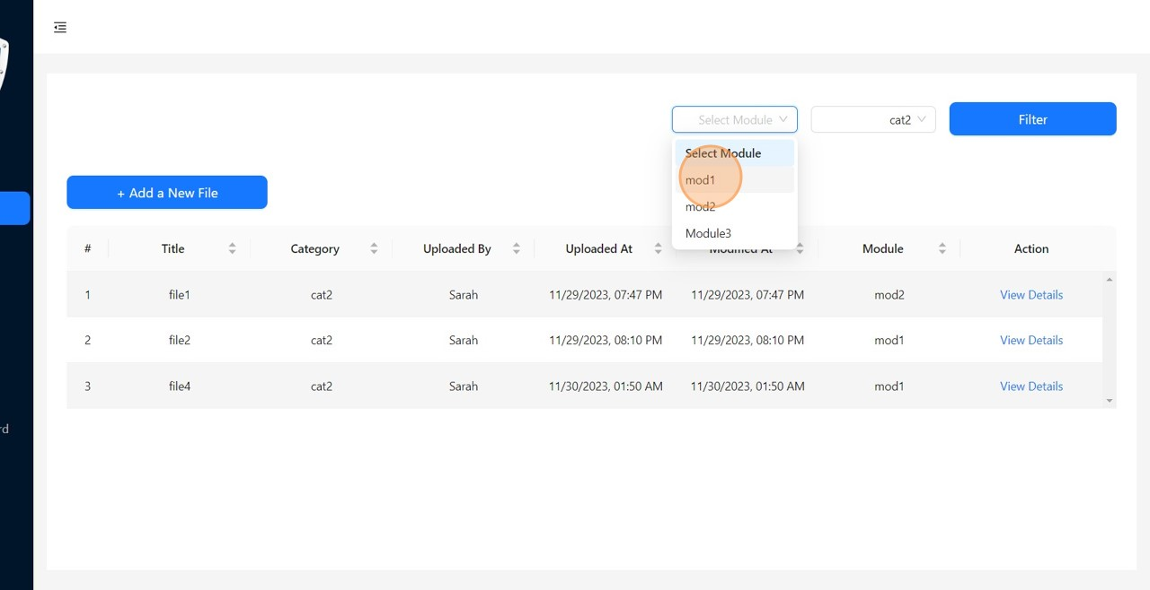

22

Click

Filter

to display a list of files filtered based on the selected module and

category.

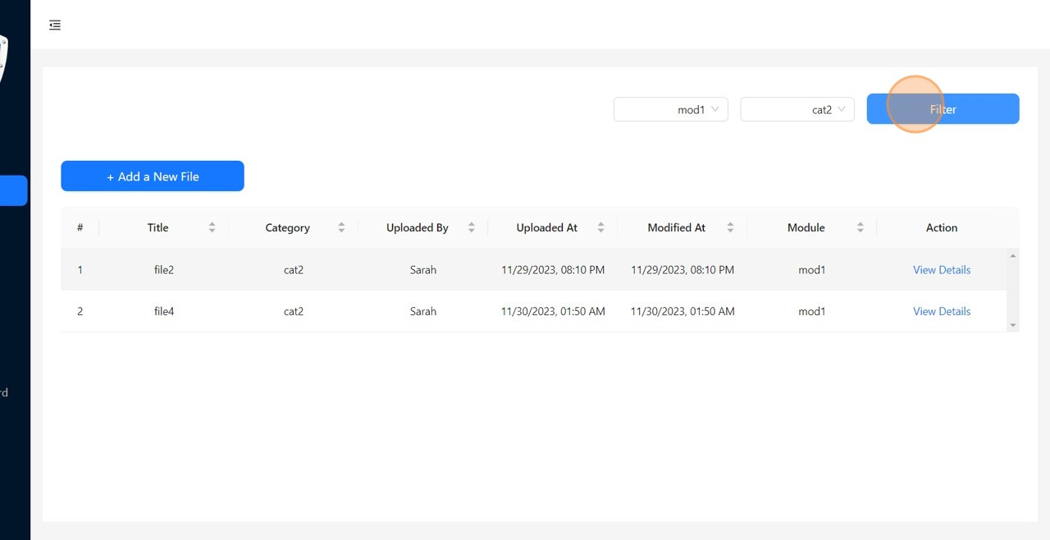

23

You can also sort the list based on any column.

Before Sort.

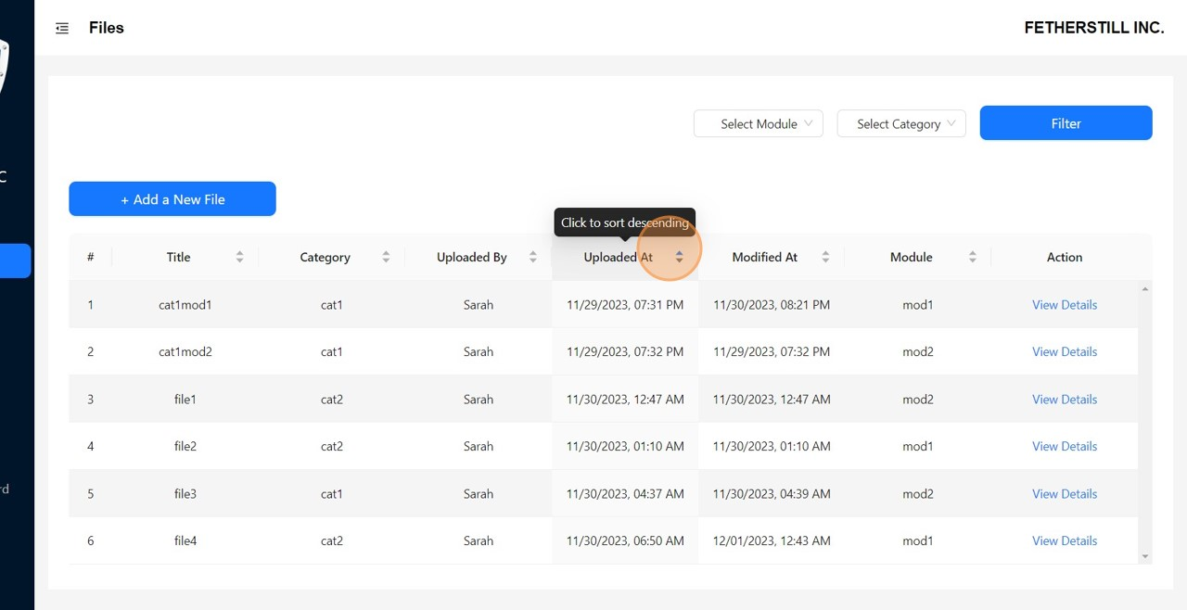

24

After Sort.

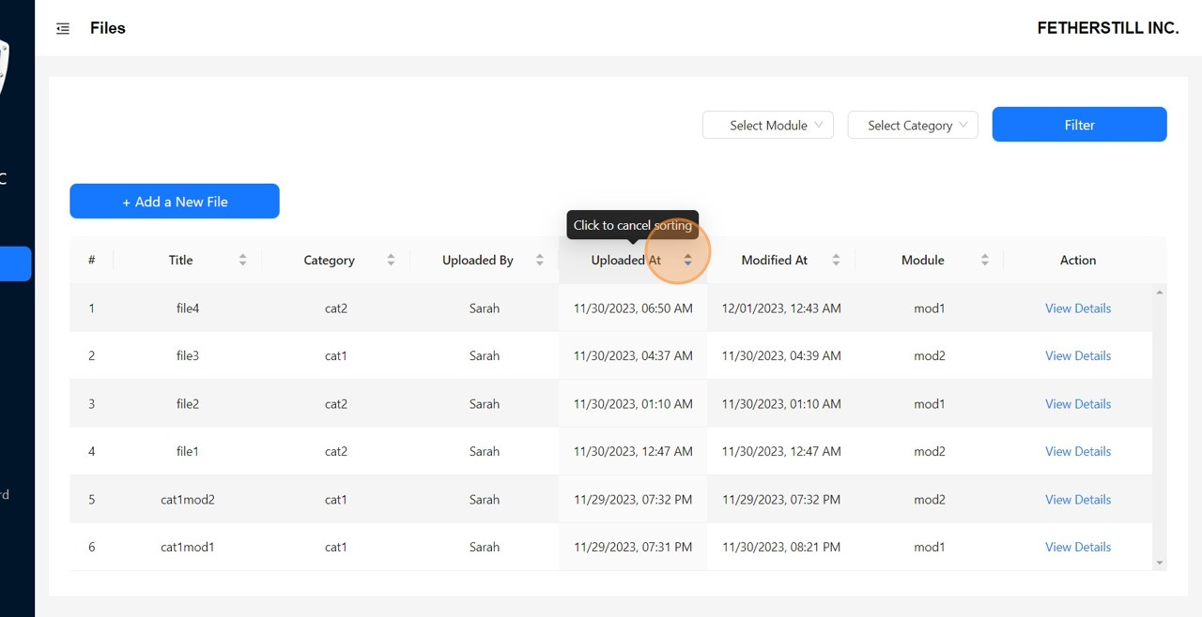

Add New File

25

Click

+

Add a New File

to upload a new file.

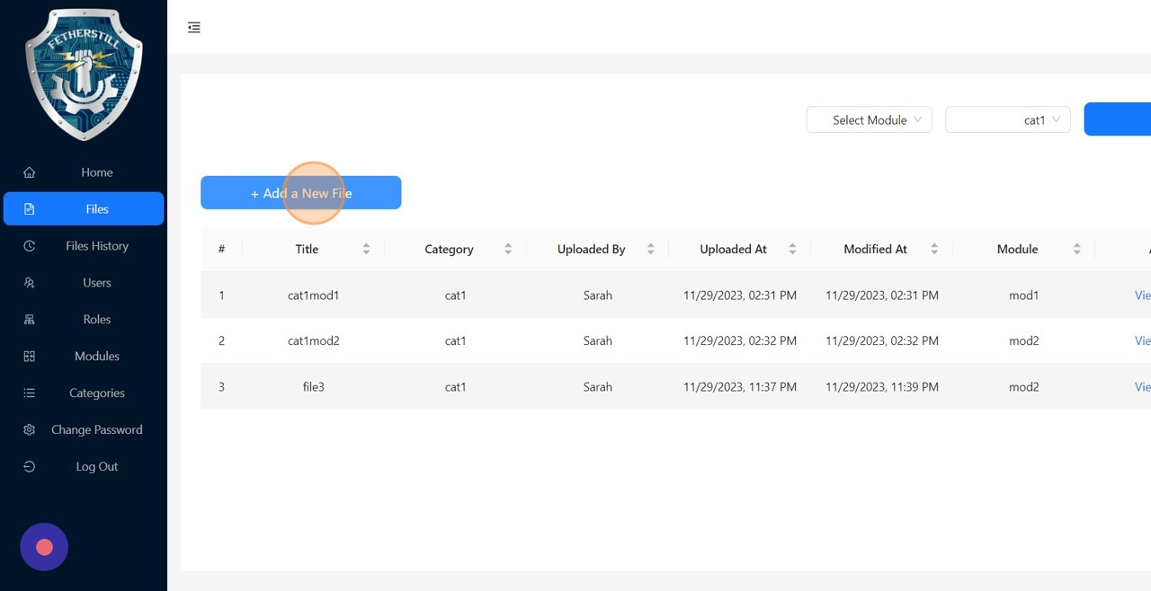

26

Fill in the form to create a new file.

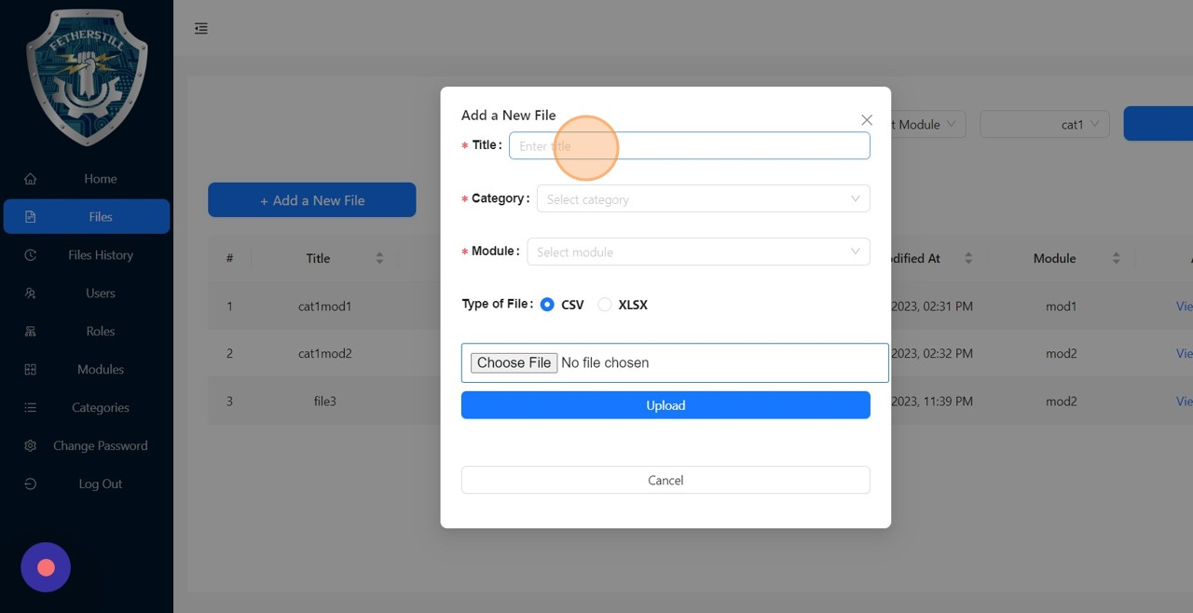

27

Select a file from your local machine to upload.

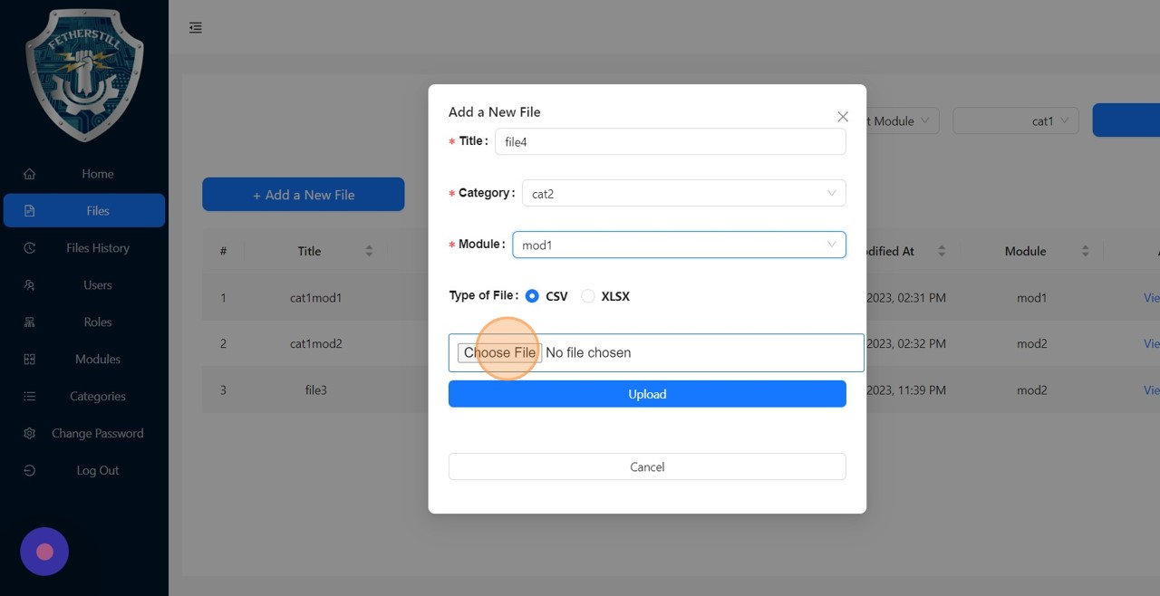

28

Click

Upload

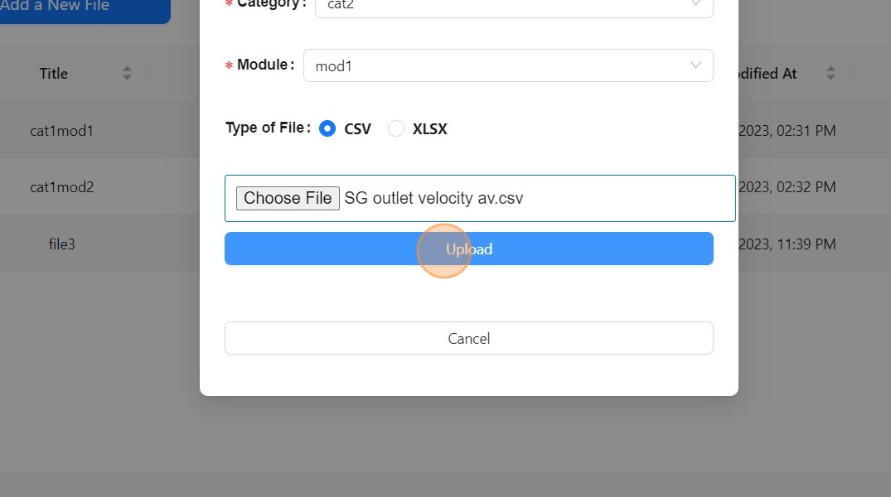

Check File History

29

Click

Files History

to access the older version of an edited files.

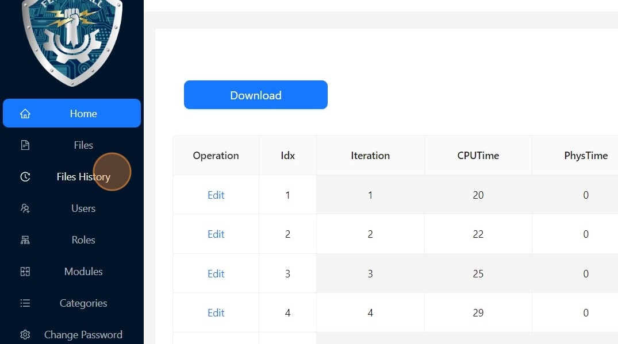

30

Click

View Details

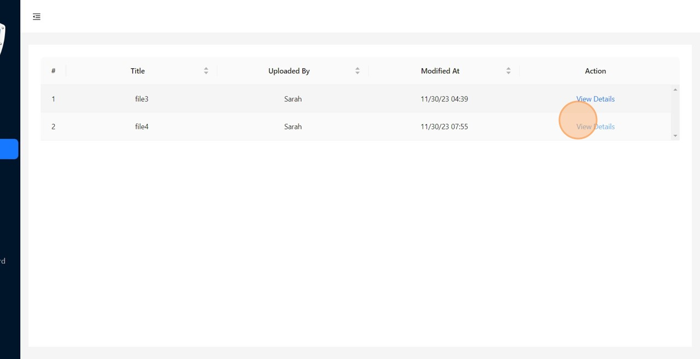

31

Toggle the switch to the ON position to display the details of the file.

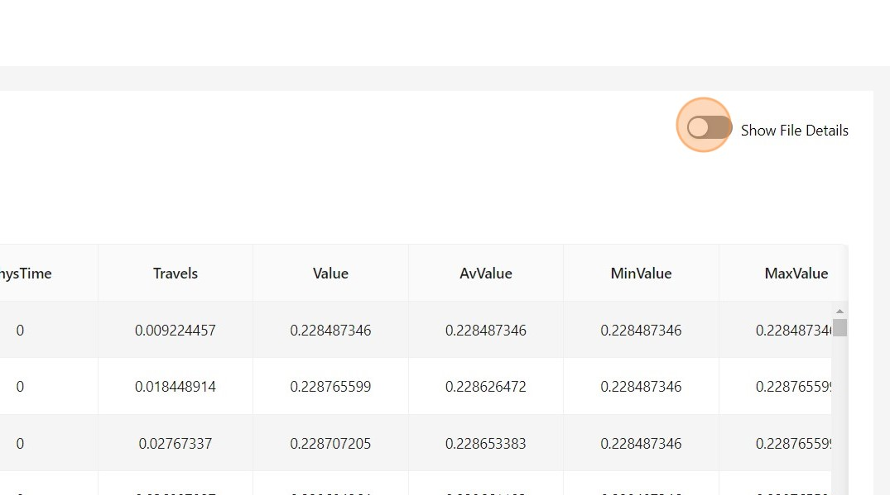

User Operations

32

Click

Users

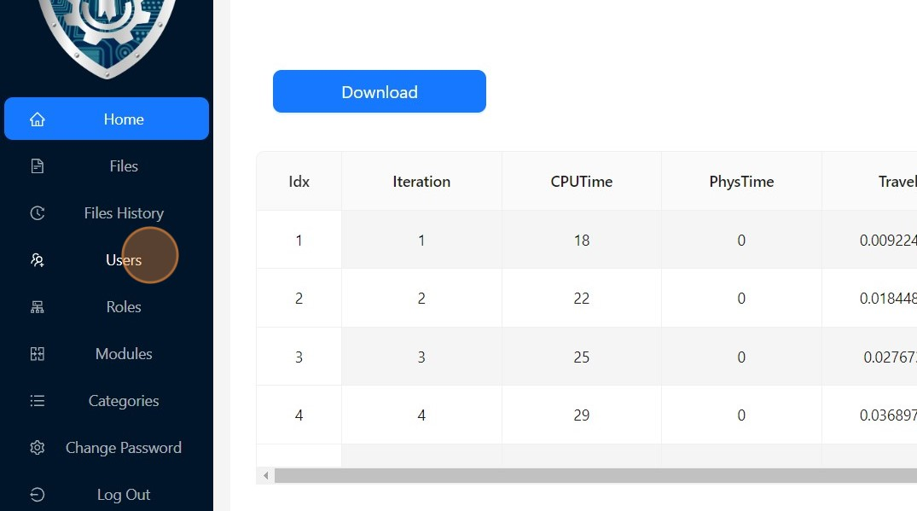

33

In the "Users" section, you can add a new user, modify an existing user's role, or

delete an existing user.

Note: The logged-in user must have permission to perform this operation.

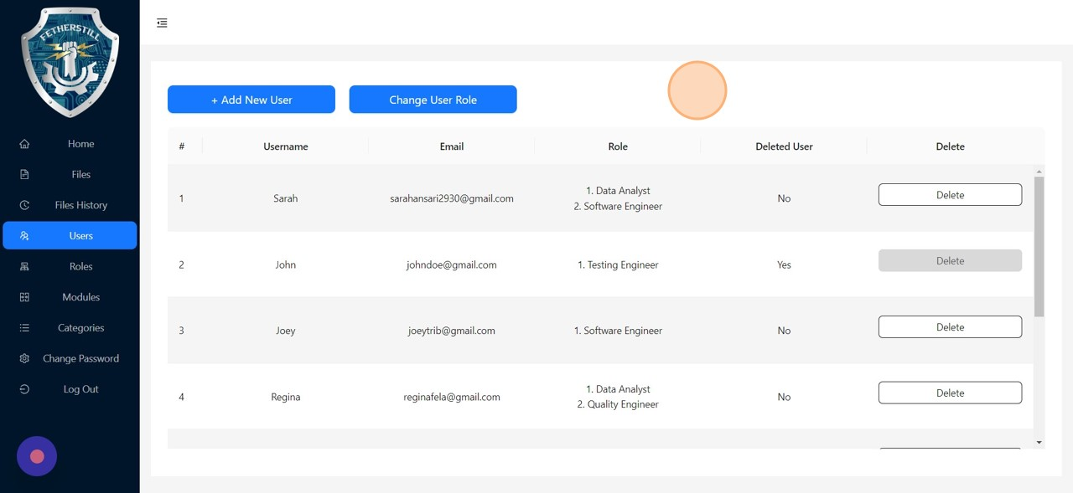

34

Click

+

Add New User

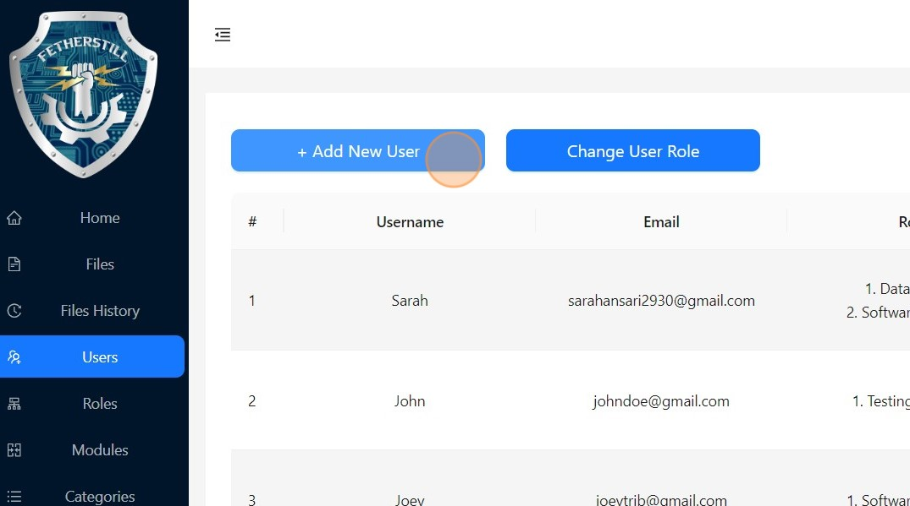

35

Fill in the details and click

Submit

to add a new user.

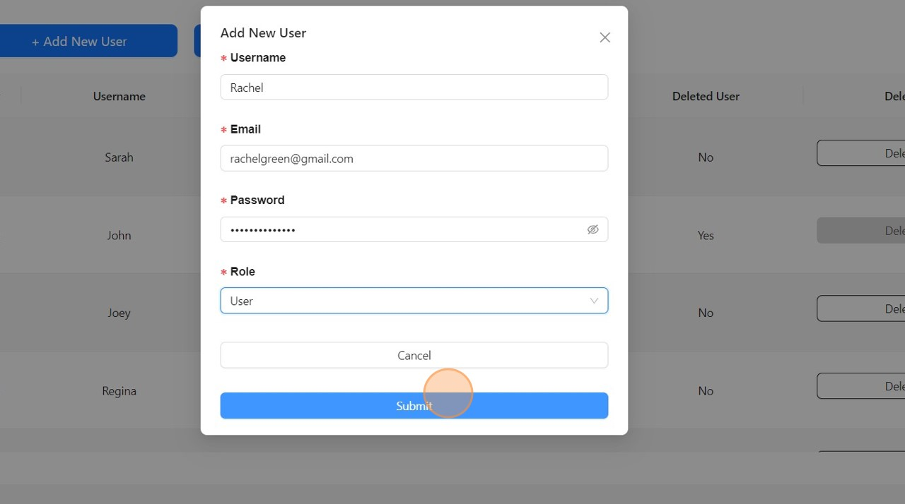

36

To change the existing user's role:

Click

Change User Role

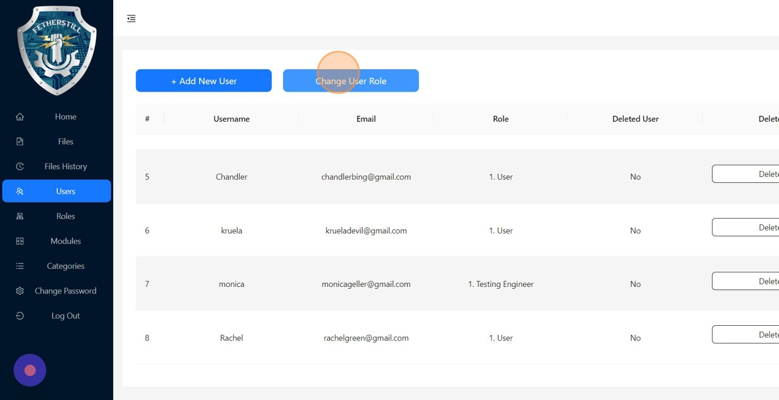

37

Select the user to change his/her role.

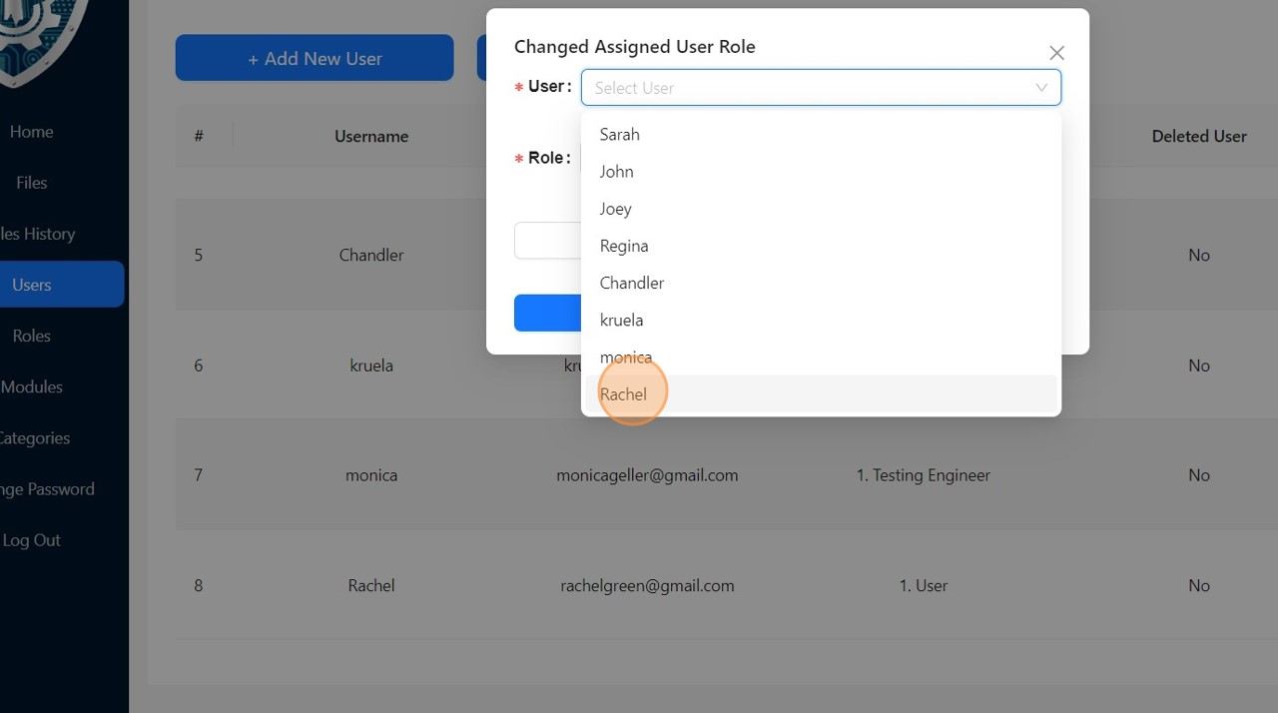

38

Select the desired role.

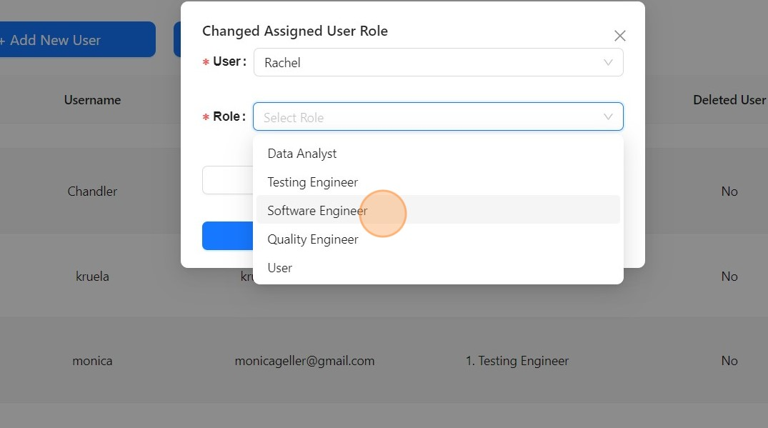

39

Click

Submit

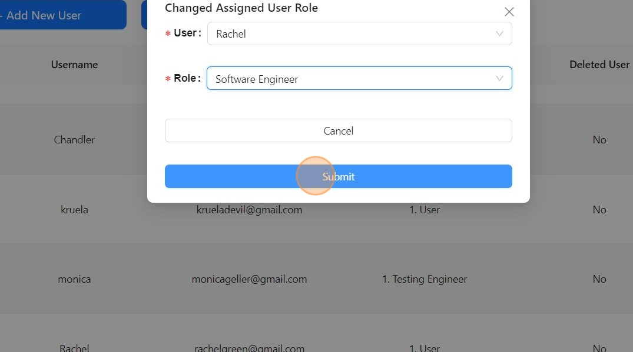

40

To delete a user, click

Delete

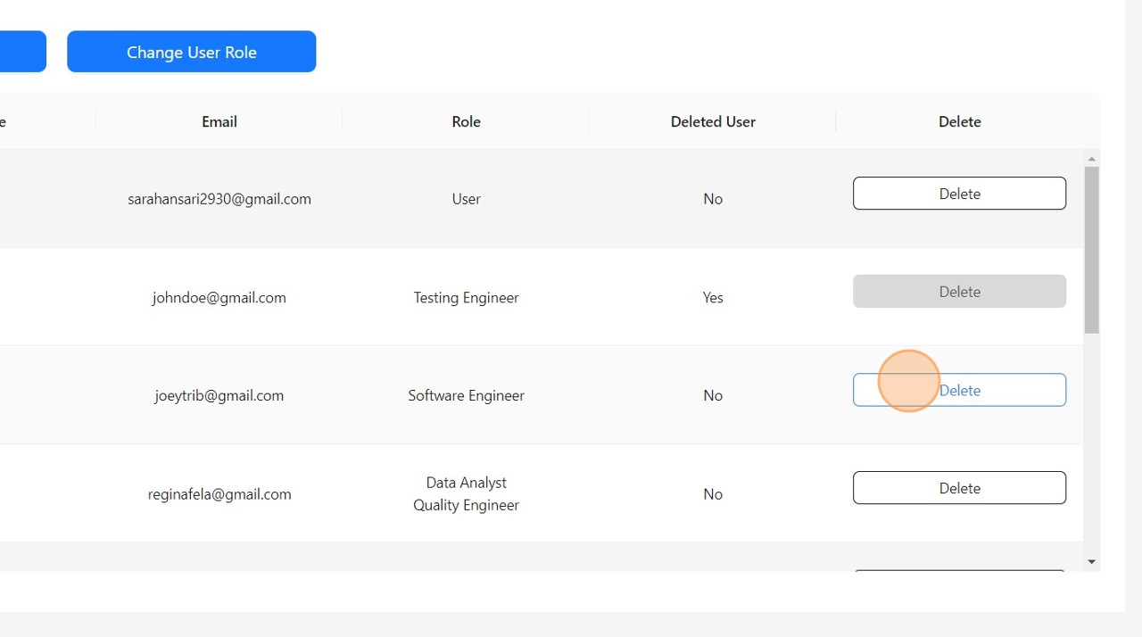

41

Confirm

Delete

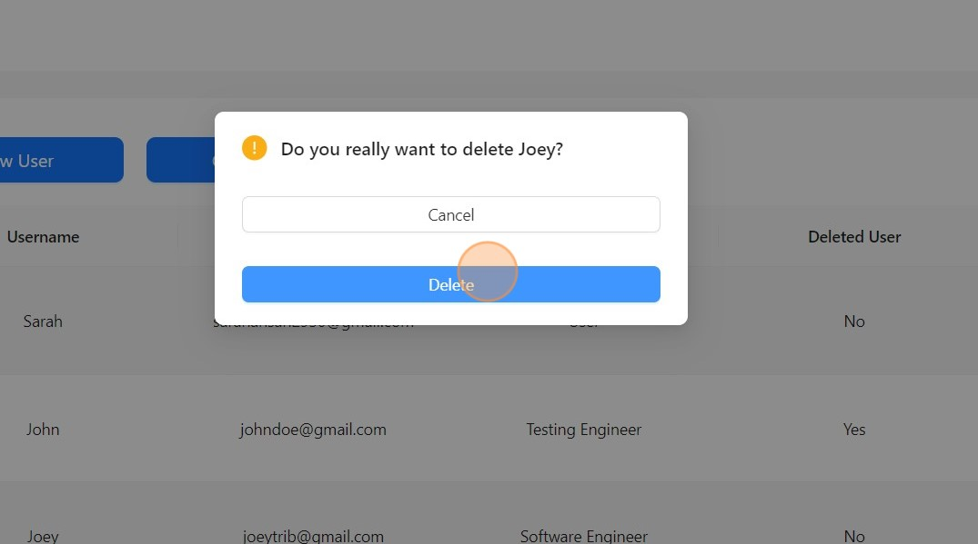

42

The user is still in the database but has been soft deleted.

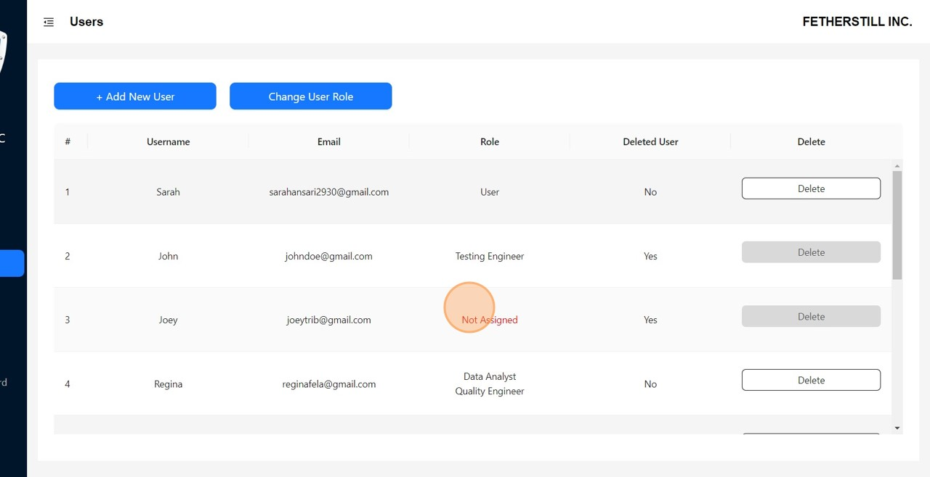

Role Operations

43

Click

Roles

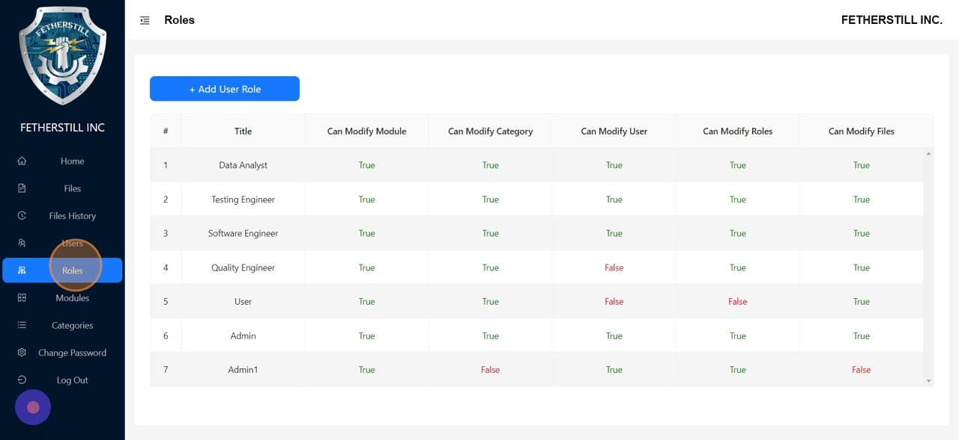

44

To add new User Role, click

+

Add User Role

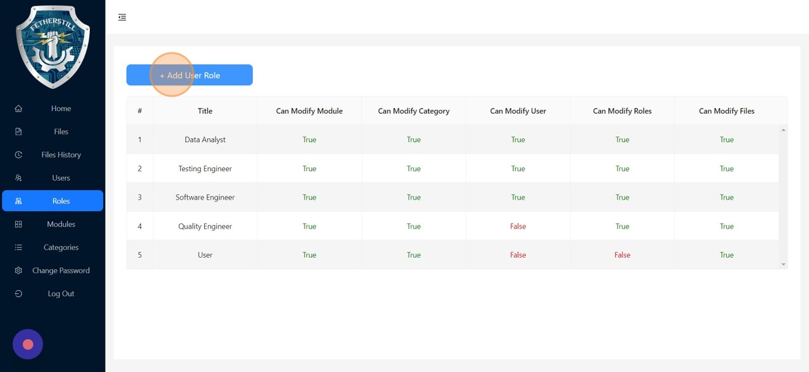

45

Fill in the form and provide the necessary permissions.

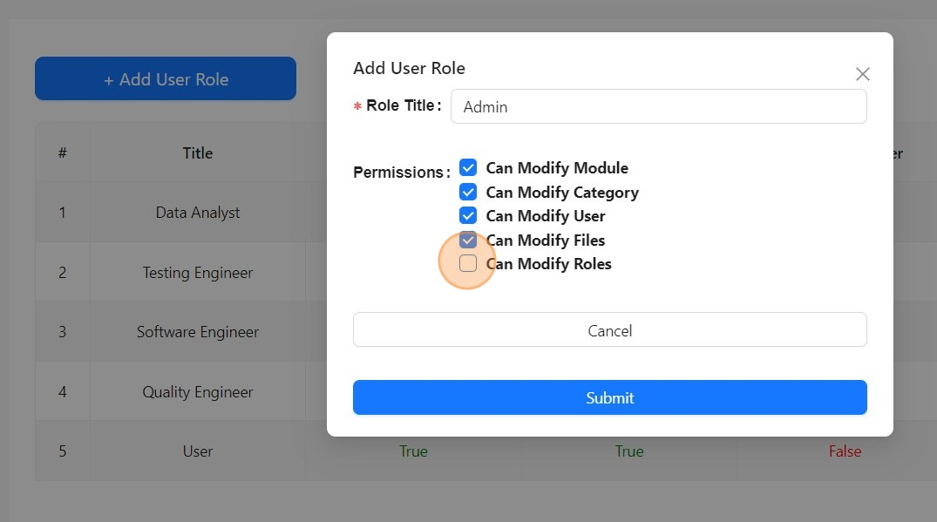

46

Click

Submit

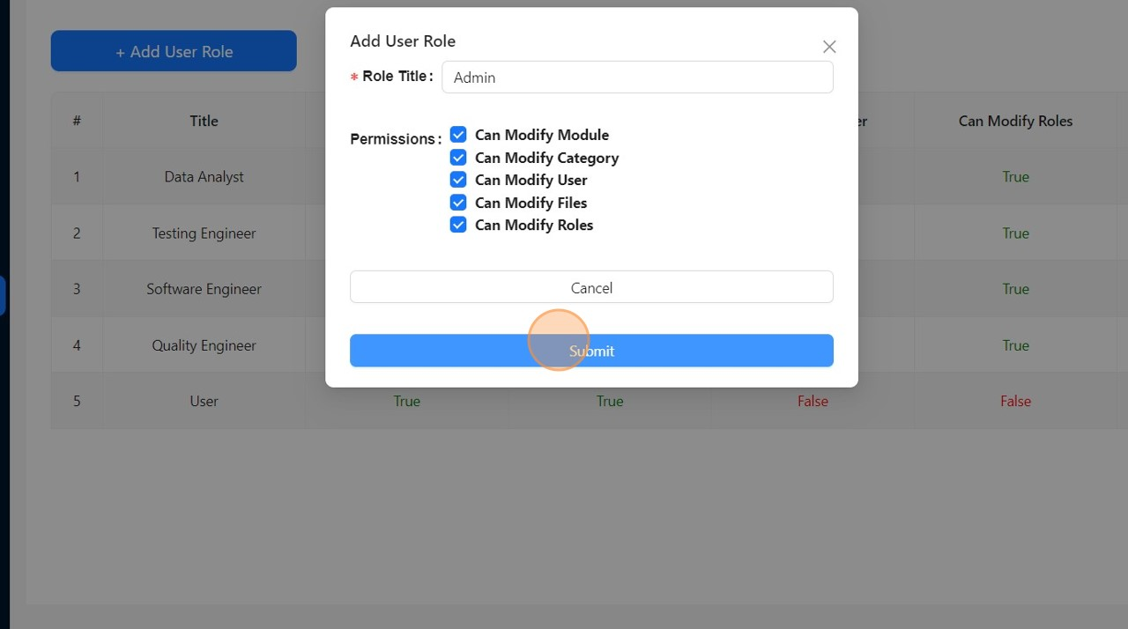

Modules & Categories Operations

47

Click

Modules

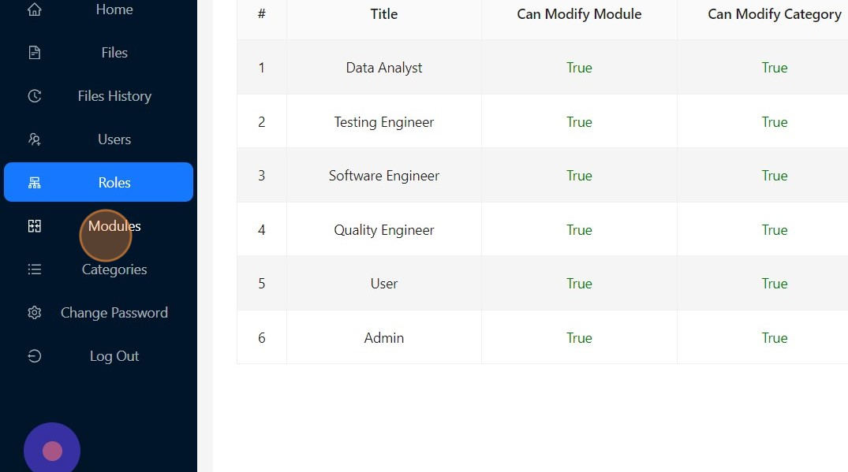

48

To add New Module click

+

New Module

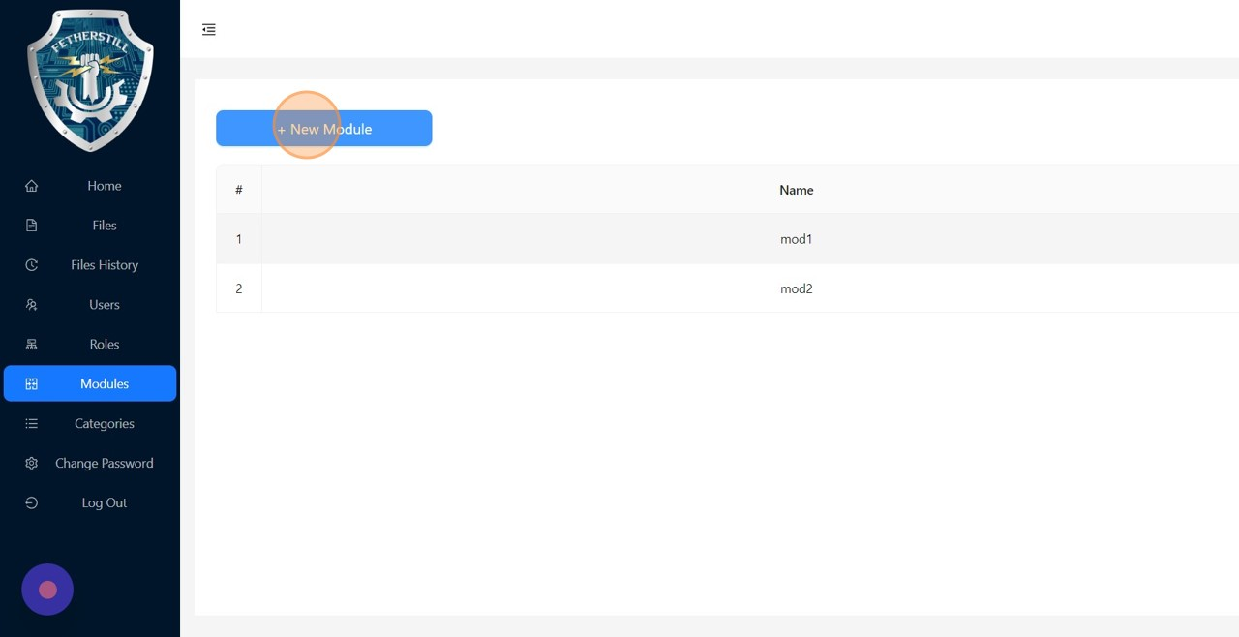

49

Enter the module name and hit

submit

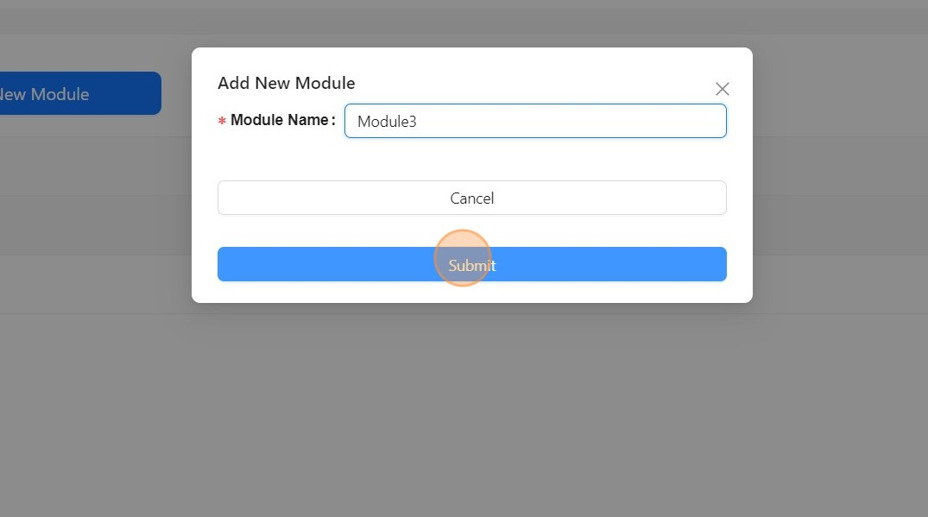

50

Click

Categories

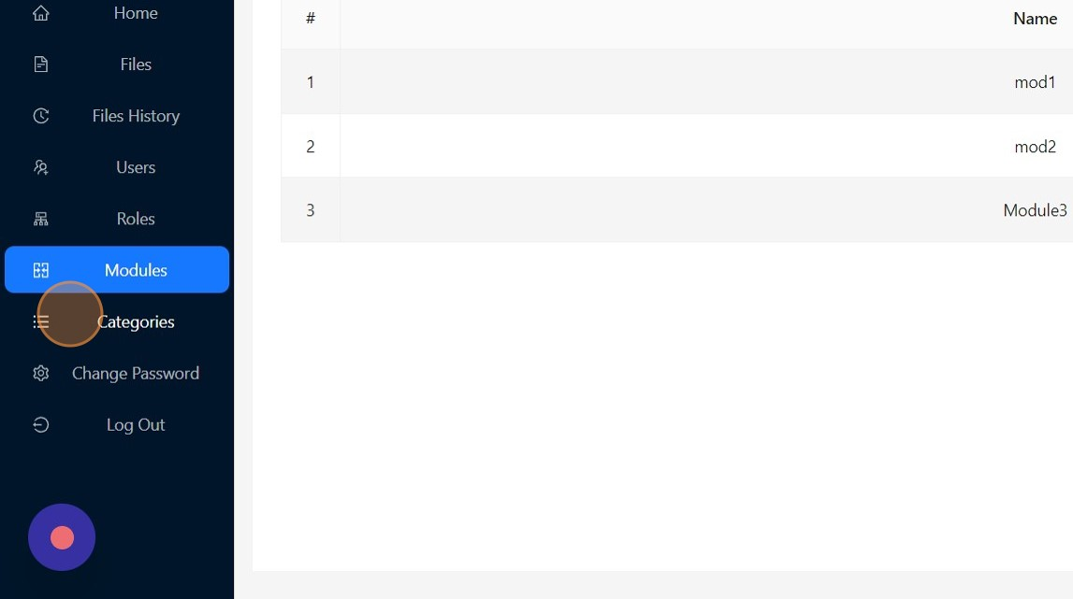

51

Click

+

New Category

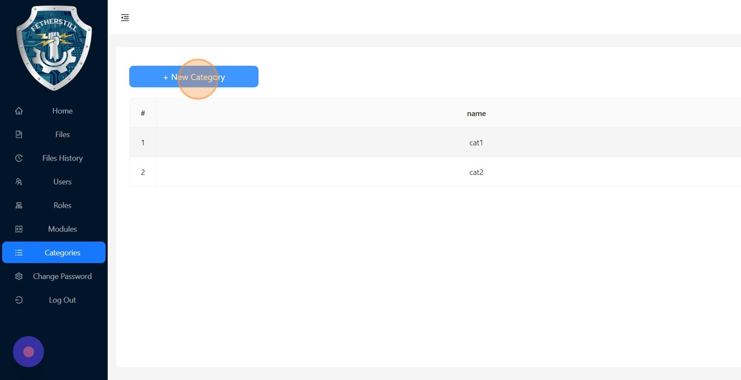

52

Enter the category name and hit

submit

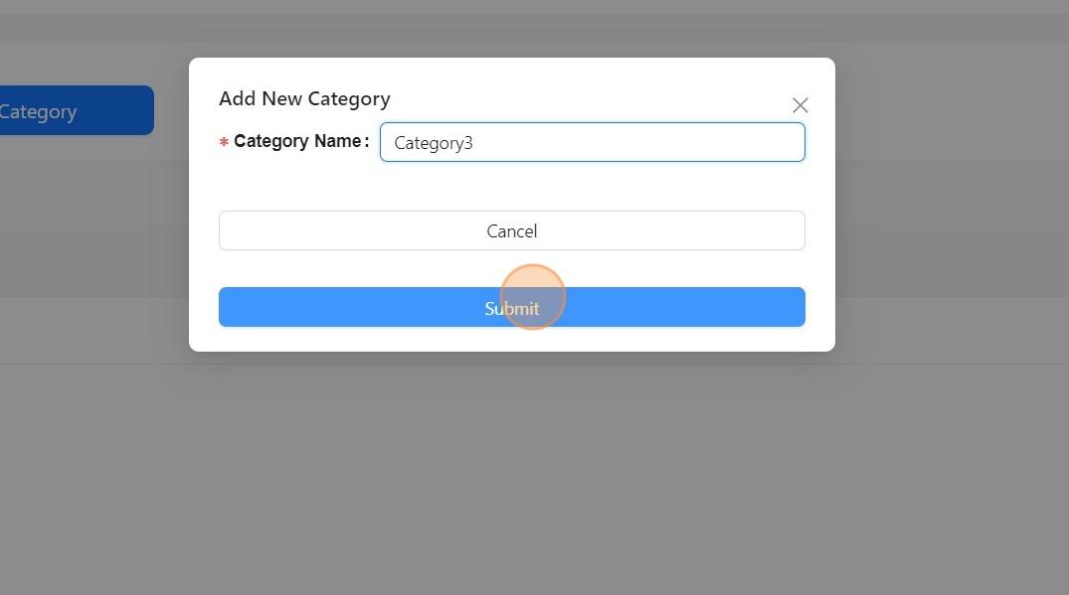

Logout

53

Click

Log Out

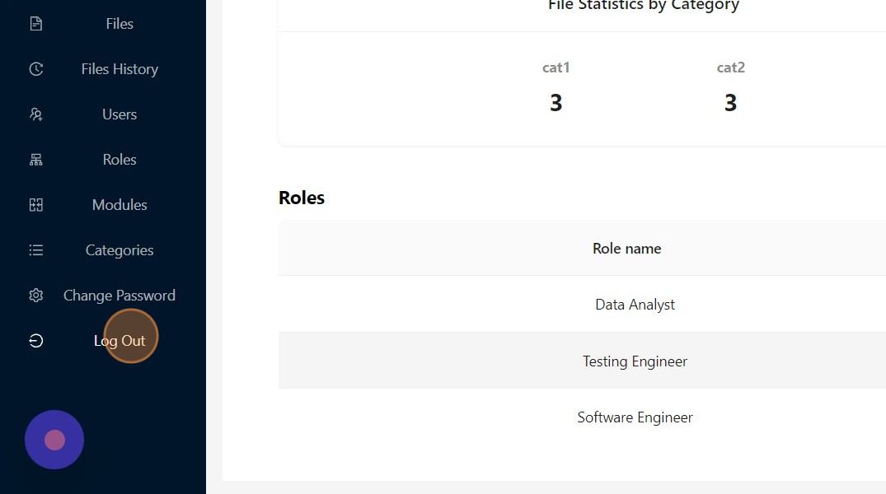

54

Logged out successfully.

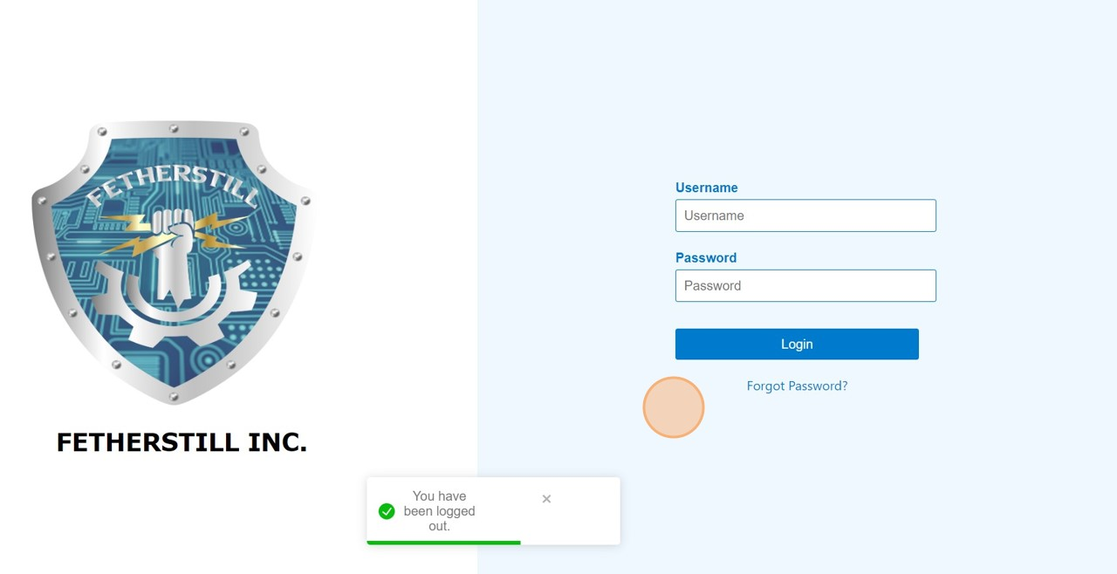

Forgot Password

55

Click "Forgot Password?"

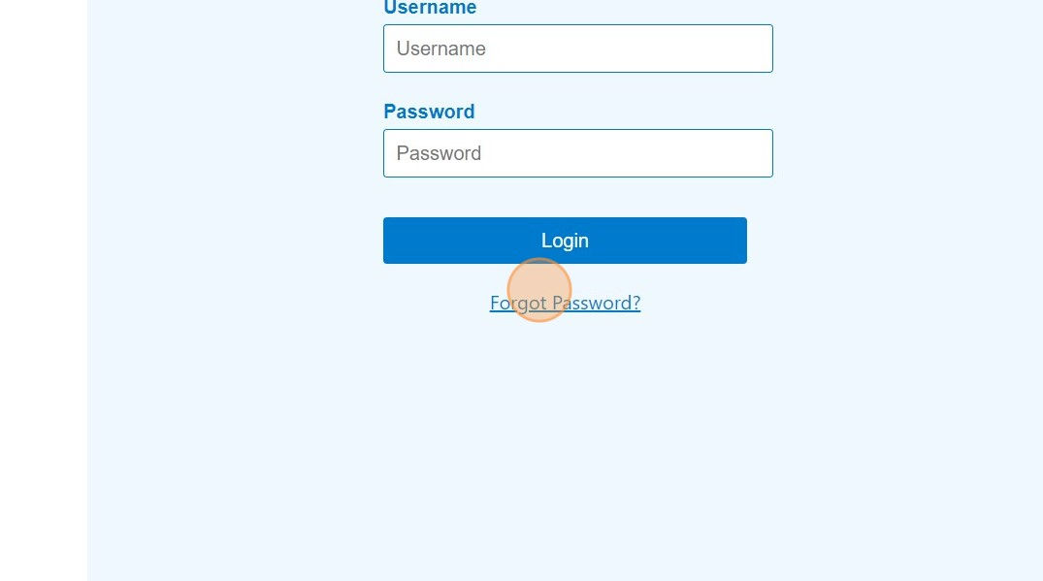

56

Enter your username and click

Submit

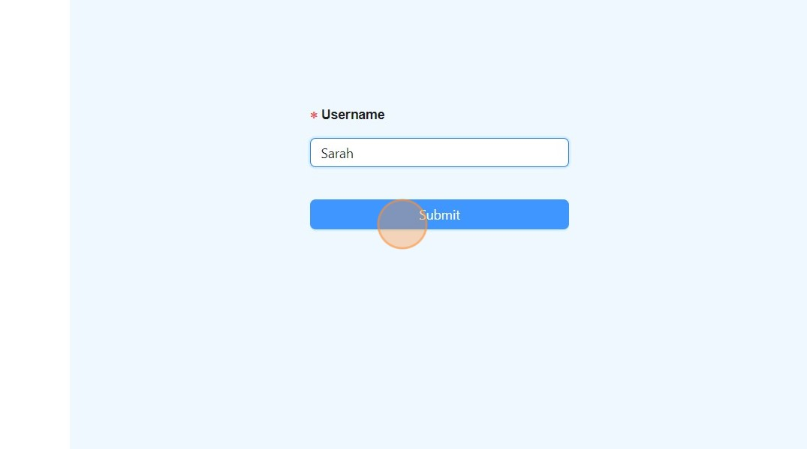

57

An email, containing a unique code, will be sent to your registered email id.

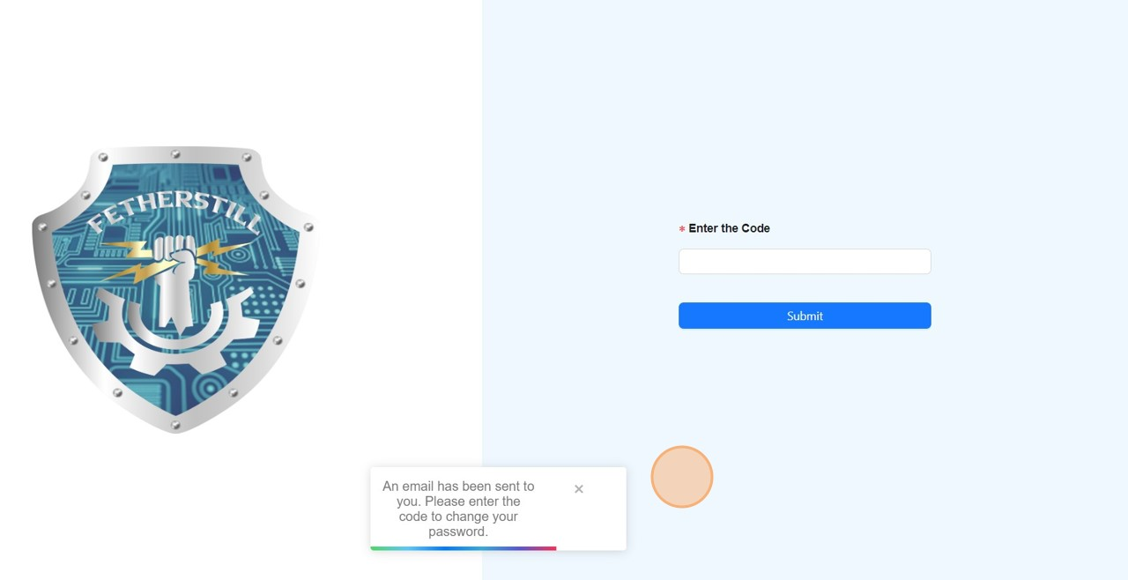

58

Check your email and copy the code.

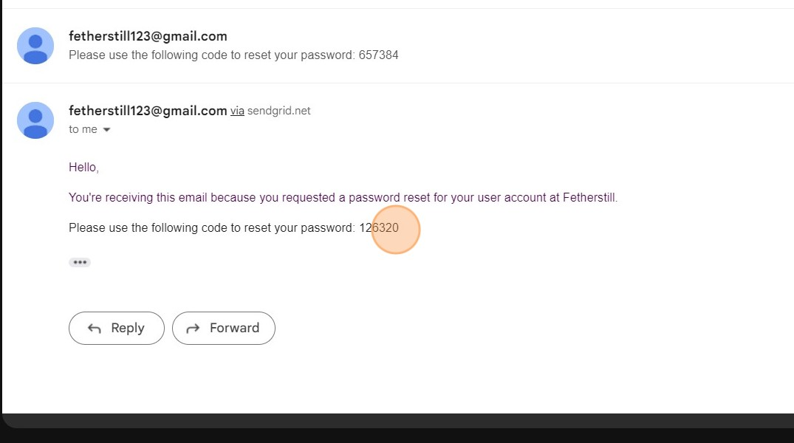

59

Enter the Code received in the email and click

submit

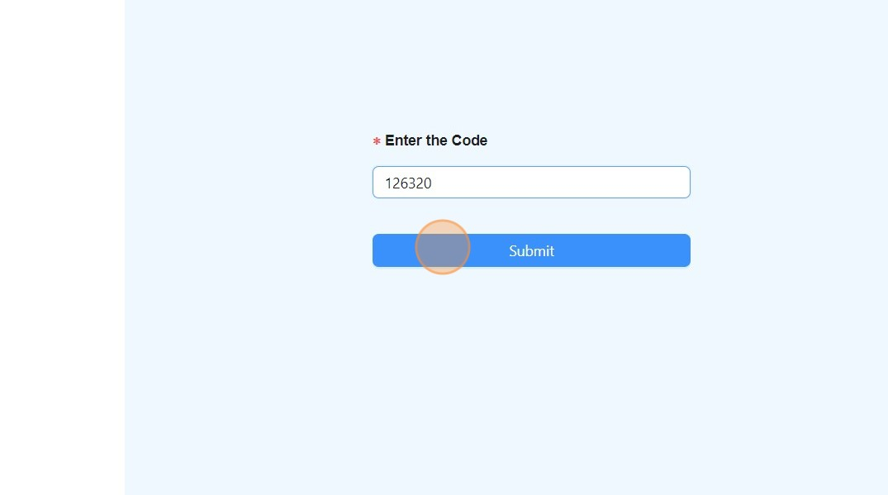

60

Enter the new password and click

Submit

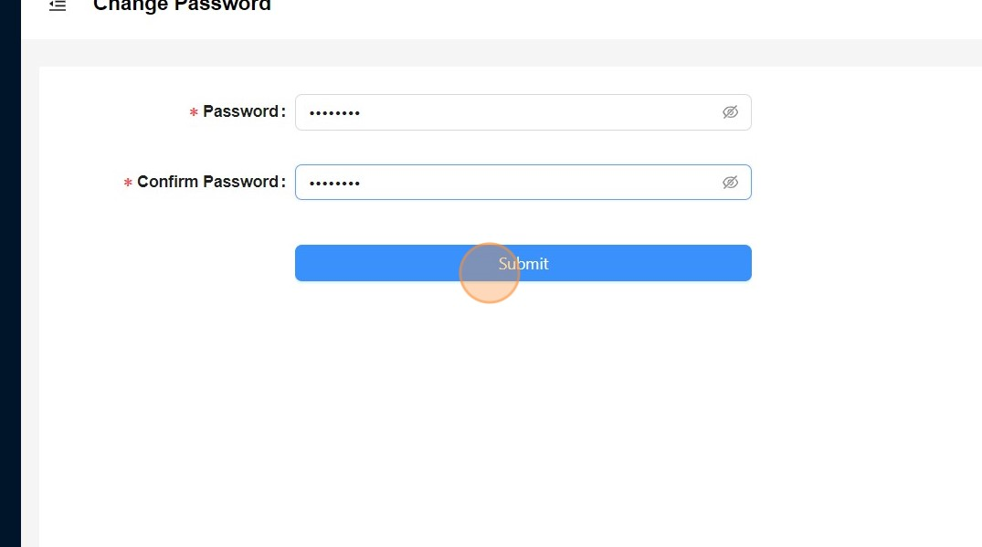

61

Password changed successfully.

